**Service Registry Service:**

Currently two services is registered in Service registry

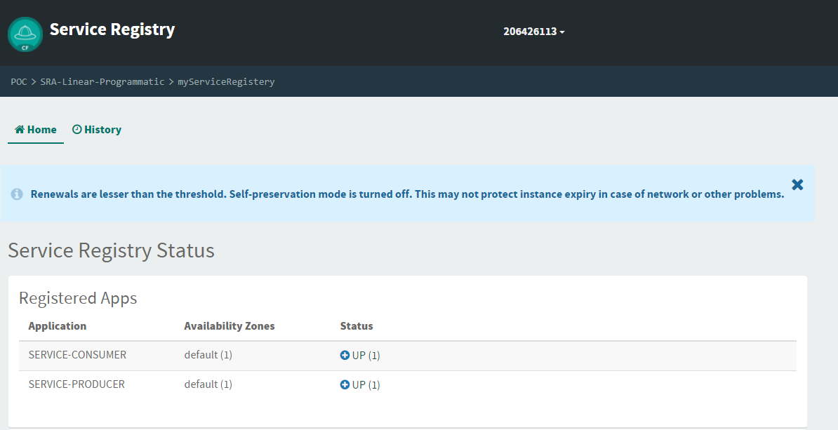

1. **Producer service**

This service produces the message

**URL**: <http://service-producer.labash.inbcu.com/produce>

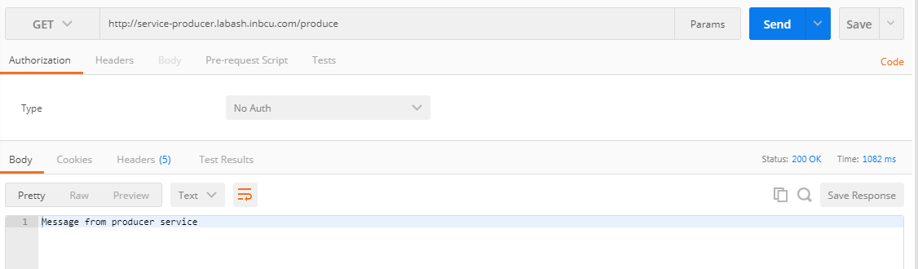

1. **Consumer Service:**

This service is to consume the message from the producer service

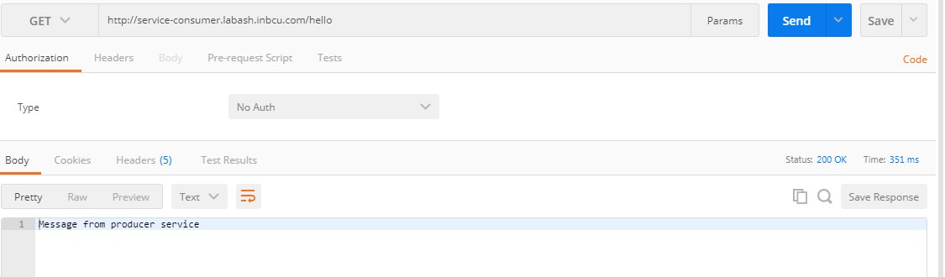

In the **Consumer Service** instead of accessing the **Route URL** (http://service-producer.labash.inbcu.com) of the producer service to get the produce message in consumer service. It is accessible via the **application name** with capital letter.

Property file of the Producer service

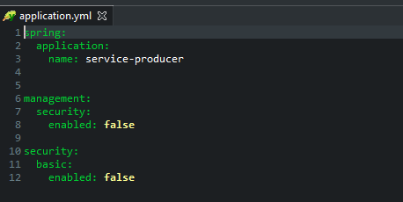

Consumer Service Code:

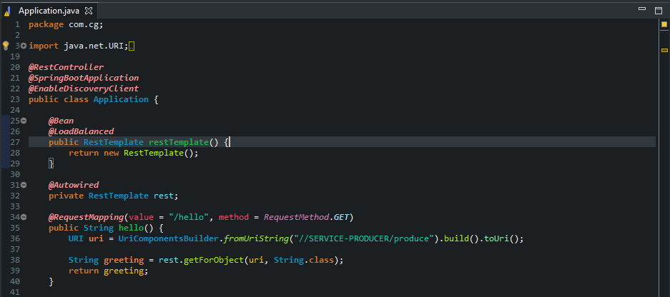

Note:

1. Whatever be the route URL of the application the service can be called by using the application name of the service.
2. If the application is scaled to 2 instance then load balanced is automatically taken care since annotation @LoadBalanced is mentioned in the RestTemplate

Producer service is scaled up to 2 instances

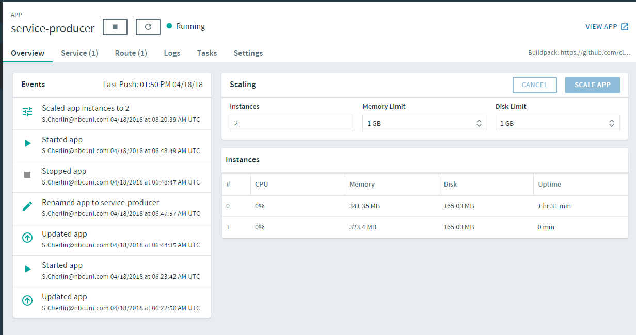

In the service registry

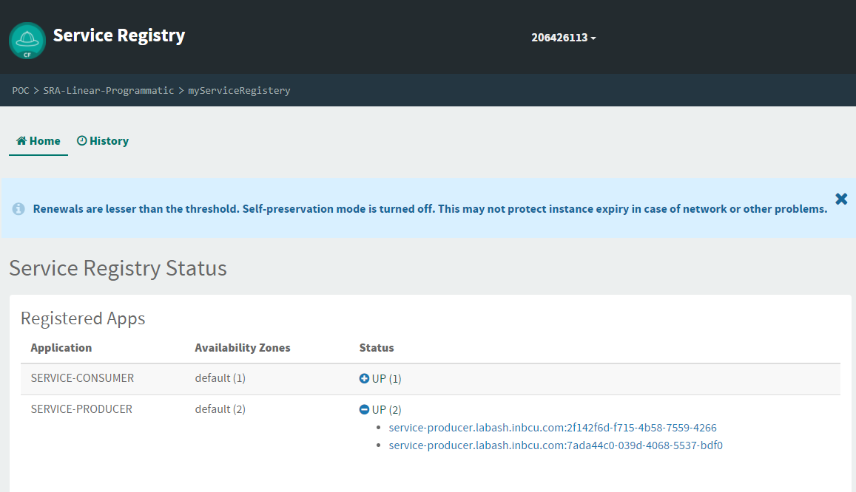

Load balance is automatically taken care:

